

**Project Title: Unified Student Experience Platform (USEP) Application**

|  |  |  |
| --- | --- | --- |
| **Name** | **Student ID** | **Member Role** |
| **Limpo Mwenya Musonda** | **2420990** | **UX/UI Designer** |
| **Madalitso Sage Banda** | **2420992** | **Business Analyst** |
| **Albert Kunda** | **2420988** | **DevOps** |

**Course Code: BSE 2210**

**Course Title: Software Design**

**Lecturer: Mr. Jacob Chikwanda**

**Group: Five (5)**

**Assignment: One (1)**

**Due Date: 18 September, 2025.**

**Part A: Design Requirements**

* Functional Requirements: login, upload assignments, view grades and notifications.
* Non-Functional Requirements: scalability, security (OAuth/JWT), cross-platform support, performance.

**Software Design**

Software Design is the discipline of structuring, modeling and planning software systems so that they are scalable, secure and maintainable while adopting to rapid changes in technology. It works in a volatile environment in which both business requirements and technologies can change. It defines the architecture, components, interfaces and data flow of a software system.

1. **Architecture Decision Records (ADRs)**

They are short documents that capture important architectural and technical decisions made during this project, along with their context and consequences.

┌─────────────────┐ ┌─────────────────┐ ┌─────────────────┐

│ Development │ │ Staging │ │ Production │

│ Environment │────│ Environment │────│ Environment │

│ │ │ │ │ │

│ • Local Testing │ │ • Integration │ │ • Multi-Region │

│ • Unit Tests │ │ • E2E Testing │ │ • Load Balancing│

│ • Code Quality │ │ • Security Scan │ │ • Auto-Scaling │

└─────────────────┘ └─────────────────┘ └─────────────────┘

1. **Artifact**

Artifact is any output byproduct or deliverable product produced during the software development process. They can be documents and models. They are in categorized based on their purposes and stage in the development lifecycle.

1. Unified Modeling Language (UML)

They are standardized visual modeling tools used in software design to represent the structure, behavior and interactions within the USEP Application. Examples of UML Diagrams

Use Case Diagram – illustrates the interactions between the actors (users, lecturers, students) and the system functionalities (USEP Web Application).

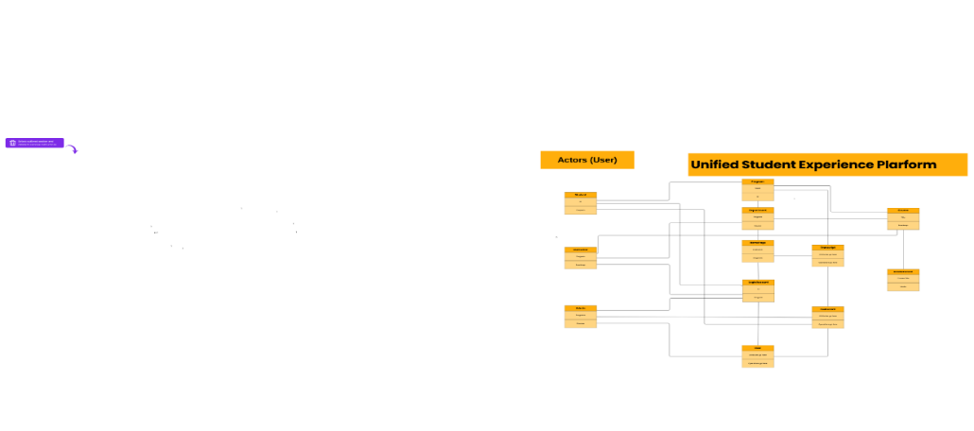

Use Case Diagram

1. **Trends**

Trends is about the effect of the software development lifecycle to automate tasks and improve decision-making. The Following are the trends for 2025 for approving for the USEP Application:

1. AI-Augmented Design – generative AI tools assist in creating architecture diagrams and UML models.
2. Cloud-Native & Serverless Evolution – server functions, containers and Kubernetes, dominate design thinking and also hybrid cloud architectures are common.
3. Micro services – are a collection of small back services separated. The USEP platform utilizes a microservices architecture to enable:

* **Independent Scaling**: Scale services based on regional demand
* **Technology Diversity**: Use optimal technology for each service
* **Cultural Customization**: Region-specific service implementations
* **Fault Isolation**: Service failures don't cascade across the platform

**Part B: Business Case for Unified Student Experience Platform (USEP)**

**The Problem**

Right now students have to hop between different apps/sites just to register for classes, check results, track finances, or join clubs.

None of these systems connect, so it’s messy, confusing, and wastes time.

Staff also end up doing more manual work → higher costs for the university.

International students face extra struggles with language and accessibility.

Students from different socioeconomic backgrounds have varying levels of technology access.

**The Solution**

Put everything in one place with USEP.

One platform for academics, support services, and student life.

Cuts down staff work by using AI (like chatbots for advising or finance reminders).

Makes life easier for students: register, see events and join clubs — all in one app.

Built to be inclusive: multilingual, mobile-friendly, and accessible for everyone.

**Outsourcing (Onshore vs Offshore)**

|  |  |
| --- | --- |
| **Onshore (same country**) | **Offshore (different country/continent)** |
| 👍 Easy communication, same culture/time zone | 👍 Cheaper, bigger talent pool. |
| 👎 Costs a lot more. | 👎 Time zone issues, possible culture/quality gaps. |

Smart move? Maybe go nearshore or a hybrid approach — balance cost savings with smooth teamwork.

**Why it’s a Genius Investment**

Students win → less stress, more support and better engagement.

Universities win → happier students = higher retention, less dropout.

Investors win → Premium features (extra services, internships, networking) = new revenue.

Can scale up from one campus → to city, national, or even global level.

More schools using it = bigger network, more profit over time.

**Part C: Cultural Intelligence Framework**

**CI/CD Pipeline Design**

**Comprehensive Pipeline Architecture**

A[Developer Commit] --> B[Git Repository]

B --> C[Webhook Trigger]

C --> D[Build Stage]

D --> E[Unit Testing]

E --> F[Code Quality Analysis]

F --> G[Security Scanning]

G --> H[Container Building]

H --> I[Integration Testing]

I --> J[Accessibility Testing]

J --> K[Performance Testing]

K --> L{Quality Gates}

L -->|Pass| M[Deploy to Staging]

L -->|Fail| N[Notify Developer]

M --> O[End-to-End Testing]

O --> P[Cultural Testing]

P --> Q[Security Validation]

Q --> R{Production Ready?}

R -->|Yes| S[Blue-Green Deployment]

R -->|No| T[Rollback]

S --> U[Post-Deployment Testing]

U --> V[Monitoring & Alerting]

**2.1 International Student Demographics Analysis**

The modern university serves students from over 100 countries, each bringing unique cultural, technological, and linguistic needs. Our cultural intelligence framework addresses these through systematic design considerations.

**2.2 Core Cultural Intelligence Requirements**

**Requirement 1: Comprehensive Multilingual Support**

**Implementation Details:**

* **Primary Languages**: English, Spanish, Mandarin, Arabic, French, German, Portuguese
* **Dynamic Language Detection**: Automatic browser language detection with manual override
* **Contextual Translation**: AI-powered translation that understands academic terminology
* **Right-to-Left (RTL) Support**: Full UI adaptation for Arabic and Hebrew languages
* **Cultural Date/Time Formats**: Localized formatting respecting regional conventions

**Technical Specifications:**

* Unicode UTF-8 encoding across all systems
* React-i18n integration for frontend internationalization
* Database schema supporting multilingual content storage
* Translation memory systems to ensure consistency
* Cultural consultant review process for all translated content

**Requirement 2: Universal Accessibility & Digital Inclusion**

**Implementation Details:**

* **WCAG 2.2 AA Compliance**: Full adherence to web accessibility guidelines
* **Screen Reader Optimization**: Semantic HTML with proper ARIA labels
* **Keyboard Navigation**: Complete functionality without mouse interaction
* **Visual Impairment Support**: High contrast modes, scalable fonts, color-blind friendly palettes
* **Cognitive Accessibility**: Simplified navigation options, clear information hierarchy
* **Low-Bandwidth Optimization**: Progressive web app features for limited connectivity

**Technical Specifications:**

* Automated accessibility testing in CI/CD pipeline
* Progressive enhancement architecture
* Offline-first design using service workers
* Responsive design tested across 200+ device configurations
* Voice interface integration for hands-free navigation

**Requirement 3: Cultural Sensitivity in User Experience**

**Implementation Details:**

* **Cultural Color Psychology**: Avoiding colors with negative connotations in specific cultures
* **Religious Considerations**: Prayer time notifications, religious holiday calendar integration
* **Cultural Communication Styles**: Adaptable UI density based on cultural preferences
* **Privacy Expectations**: Configurable privacy levels respecting cultural norms
* **Academic Calendar Variations**: Support for different educational year structures globally

**AI Integration & Ethics**

**6.1 AI Opportunities in USEP**

**Primary AI Implementation: Intelligent Academic Advisor**

**Functionality**:

* **Personalized Course Recommendations**: Based on academic history, career goals, and cultural background
* **Degree Progress Tracking**: Automated analysis of graduation requirements
* **Study Schedule Optimization**: AI-powered timetable suggestions considering cultural preferences
* **Early Warning Systems**: Predictive analytics for at-risk student identification
* **Multilingual Support**: Natural language processing in 15+ languages
* **User6 search optimization**

**Technical Implementation**:

* **Machine Learning Models**: TensorFlow/PyTorch for recommendation engines
* **Natural Language Processing**: Transformer models for multilingual chat support
* **Knowledge Graphs**: Semantic understanding of academic relationships
* **Federated Learning**: Privacy-preserving model training across regions

**Expected Benefits**:

* **Student Retention**: 15% improvement in first-year retention rates
* **Academic Performance**: 20% increase in on-time graduation
* **Support Efficiency**: 60% reduction in manual advising workload
* **Cultural Adaptation**: Personalized experience for international students

**Conclusion**

* The Unified Student Experience Platform represents a transformative opportunity to demonstrate how modern software development practices can create truly inclusive, secure, and sustainable educational technology. By embracing cultural intelligence as a first-class architectural concern, implementing robust DevSecOps practices, and approaching AI integration with ethical rigor, we can build a platform that not only serves today's diverse student population but evolves to meet the needs of future learners worldwide.
* The success of USEP will be measured not just in technical metrics, but in its ability to break down cultural barriers, democratize access to education, and empower students from all backgrounds to achieve their academic goals. This documentation provides the foundation for building such a platform—one that truly embodies the university's commitment to design that lasts beyond 2025.